## Exercise 2.1.4: Using the Console

In this exercise, we will learn how to open the console, and how to use it!

There are a couple of ways to open the console:

**On a Mac:**

* Type Command + Option + j

**On a PC:**

* Ctrl + Shift + j

Alternatively, you can right click the webpage and click the **Inspect** button.

Once you do this, you should see the console. Here is a snapshot of what the Chrome console looks like:

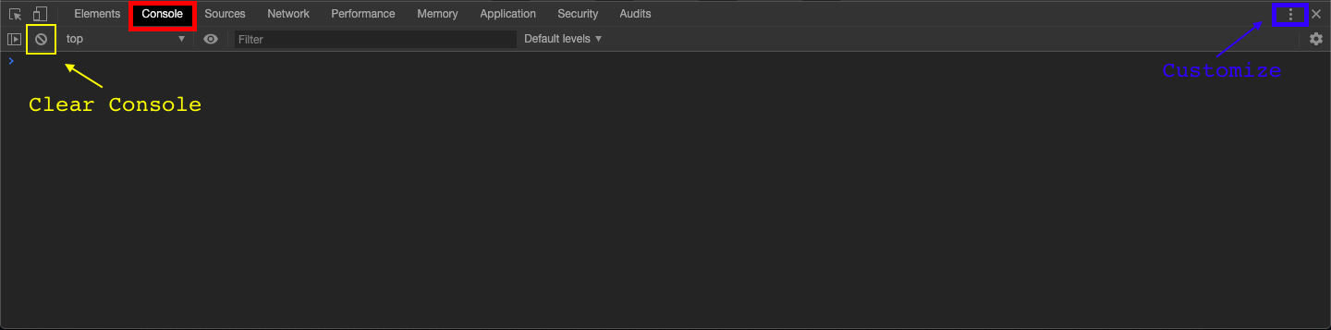

1. Before starting, click the Customize button. This will allow you to change the location of the console on your browser. Which location did you choose?
2. We can actually write JavaScript directly into the console. This can be useful if you need to do quick equations or to check if the values in your program are correct. Let’s give it a try.
   * a. Directly in the console, create a variable num, and set it equal to 5. Then click enter. What happens?
   * b. Now type num directly into the console. What happens? What does this tell you about how the console works?
   * c. Type num + 5 into the console. Notice how the value appears before you hit enter - how could this be a helpful feature?
3. What happens when you write console.log("Karel") into the console?